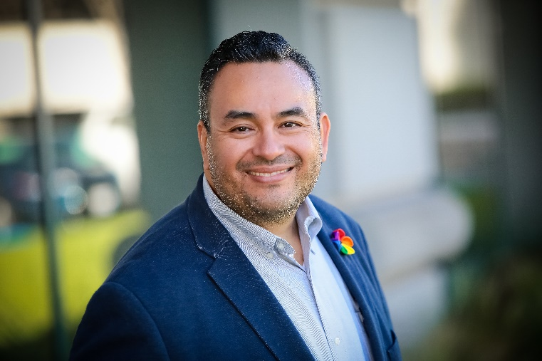
NABIL HASSAN EL-GHOROURY, PH.D.
Nabil Hassan El-Ghoroury, PhD, CAE, is the Executive Director of the California Association of Marriage and Family Therapists (CAMFT). In this role, he represents over 32,000 marriage and family therapists and trainees in the state of California.
Prior to going to CAMFT, Nabil served as Associate Executive Director at the American Psychological Association (APA), where he directed the American Psychological Association of Graduate Students (APAGS), the graduate student group within APA. In this role, he functioned as the CEO of a medium-sized association (approximately 28,000 members), providing leadership, management, coordination and evaluation of all projects and activities for the organization.
Dr. El-Ghoroury practiced as a pediatric psychologist for 7 years at MetroHealth Medical Center. He was faculty in Case School of Medicine in Pediatrics and the Center for Reducing Health Disparities. He was also adjunct faculty in the Department of Psychology at Case Western Reserve University. Nabil saw patients with a variety of mental health and health conditions in the Pediatrics Department, served as the consulting psychologist for a bilingual pediatric primary care clinic. As his clinic’s only bilingual (Spanish-speaking) mental health provider at the time, Nabil treated many monolingual Spanish-speaking and bilingual children and families. While he was working at MetroHealth, he received loan repayment through the National Health Service Corps Loan Repayment Program.
His peers for his work have recognized Nabil. He won the Student Research Prize from the Autism Special Interest Group of the Association for the Advancement of Behavior Therapy for his master’s thesis examining how family members played with children with autism. He was awarded the Achievement in Public Information Award by the Ohio Psychological Association in recognition of providing media outreach in Spanish after the Virginia Tech shooting. Most recently, he was accepted into American Society of Association Executives (ASAE) Diversity Executive Leadership Program for 2016-2018.
Dr. El-Ghoroury has been involved in associations as a leader. He was a founding board member of the American Arab, North African, and Middle Easter Psychological Association. He served as Chair of the Committee on Early Career Psychologists for APA. He volunteered as Chair of the Public Education Campaign for the Ohio Psychological Association. He was a student representative to the APA Ethics Code Task, where he helped update the ethical standards that are followed by all psychologists in the US. Currently he serves on the Ethics Committee for ASAE.
Nabil has presented at numerous national conferences on topics related to student and professional development in psychology, leadership opportunities for graduate students, social media, and health and educational disparities in autism. He has spoken frequently about how to afford graduate school and has described the NHSC Loan Repayment Program to numerous audiences of students and recent doctorate.
He was a keynote speaker for the 2012 Hawaii Psychological Association annual conference. Fully fluent in Spanish, he has presented in Spanish at several conferences in Latin America, including Ecuador, Bolivia, Colombia, and Cuba.
Nabil received his Bachelor’s in psychology from the University of California, Los Angeles, and his Ph.D. in clinical psychology from Binghamton University.
EDUCATION
- State University of New York at Binghamton
Ph.D., Clinical Psychology, 2002,
M.A., Clinical Psychology, 1998
- University of California, Los Angeles
B.A., Psychology, concentration in Developmental Disabilities, 1992

LICENSURE/CERTIFICATION
- Psychology License, Ohio # 5983
- Certified Association Executive (CAE)

EMPLOYMENT
- California Association of Marriage and Family Therapists (CAMFT) Executive Director,
2018 – present
    - Executive Director of a 32,000 member 501(c)6 organization, $5 million budget
    - Responsible for 5 direct reports, 25 total staff
    - Responsible for providing leadership, direction, coordination, evaluation, management, and supervision for all activities, projects, initiatives, budgets, and strategic planning
    - Serves as primary staff liaison for the Board of Directors, Strategic Planning Committee, CAMFT Political Action Committee (state and federal PACs), Bylaws Committee, and Nominating Committee
    - Responsible for lobbying and advocacy efforts at the state and federal levels
    - Primary staff liaison for the CAMFT Educational Foundation, a 501(c)3 organization, and the Strategic Planning Committee for the Foundation
    - Builds relationship with external stakeholders, including California Board of Behavioral Sciences, American Association of Marriage and Family Therapists, MFT Consortiums throughout the state, and the Irregulars
    - Oversees, advises, and implements

